**Task No. 1:** You are working on an application that have utility to turn flashlight of smartphone On/Off and have a requirement to add ringtones and effects for flashlight in an application, Implement Decorator pattern for adding ringtone functionality in an application that have a basic functionality of flashlight only. decorate an application with

ringtones and flashlight effects using Decorator.

**Solution:**

**Interface IMobileApp**

interface IMobileApp

{

string getfeatures();

}

**Class Flashlight**

class flashlight : IMobileApp

{

public string getfeatures()

{

return "It has only flashlight features";

}

}

**Abstract Class MobileAppDecorator**

abstract class MobileAppDecorator : IMobileApp

{

protected IMobileApp name;

public MobileAppDecorator(IMobileApp name)

{

this.name = name;

}

public virtual string getfeatures()

{

return name.getfeatures();

}

}

**Class Flashlighteffects**

class flashlightEffects : MobileAppDecorator

{

public flashlightEffects(IMobileApp name) : base(name) { }

public override string getfeatures()

{

SOS_effects(name);

return name.getfeatures();

}

public void SOS_effects(IMobileApp name)

{

Console.WriteLine("SOS effects of flashlight has been added . ");

}

}

**Class Ringtone**

class ringtone : MobileAppDecorator

{

public ringtone(IMobileApp name) : base(name)

{

}

public override string getfeatures()

{

return name.getfeatures() + "\nRingtone functionality is added :-)";

}

}

**Main Method**

static void Main(string[] args)

{

Console.WriteLine("----------Without Decorator------------");

IMobileApp obj = new flashlight();

Console.WriteLine(obj.getfeatures());

Console.WriteLine("----------With Decorator---------------");

IMobileApp obj2 = new ringtone(obj);

Console.WriteLine(obj2.getfeatures());

Console.WriteLine("----------------------------------------");

IMobileApp obj3 = new flashlightEffects(obj);

Console.WriteLine(obj3.getfeatures());

}

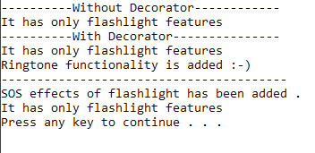**Output:**